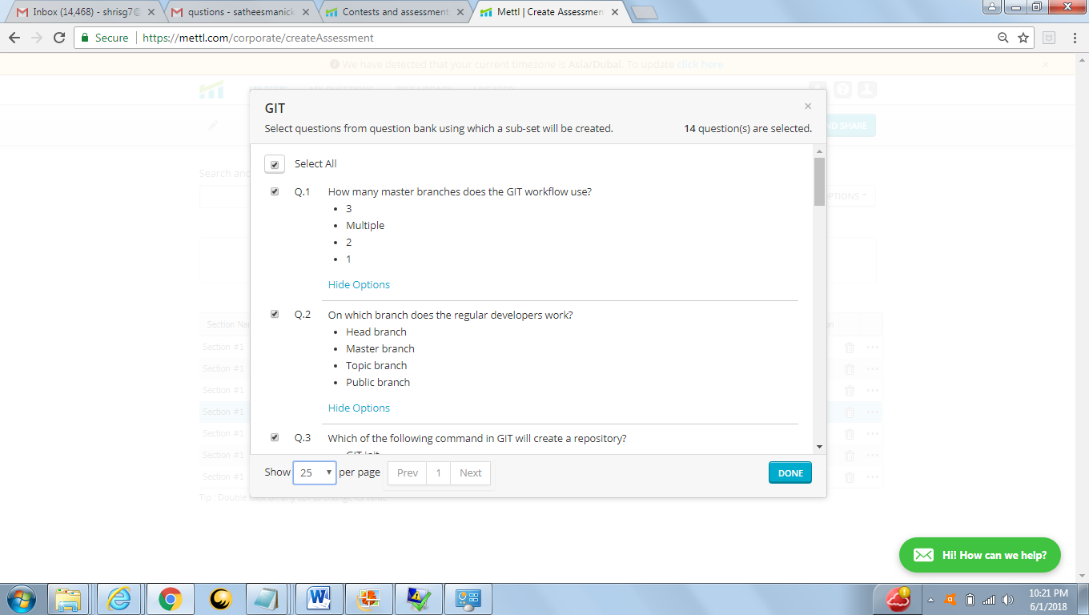

Question 1: B (Multiple)

Qusetion 2: B (Master Branch)

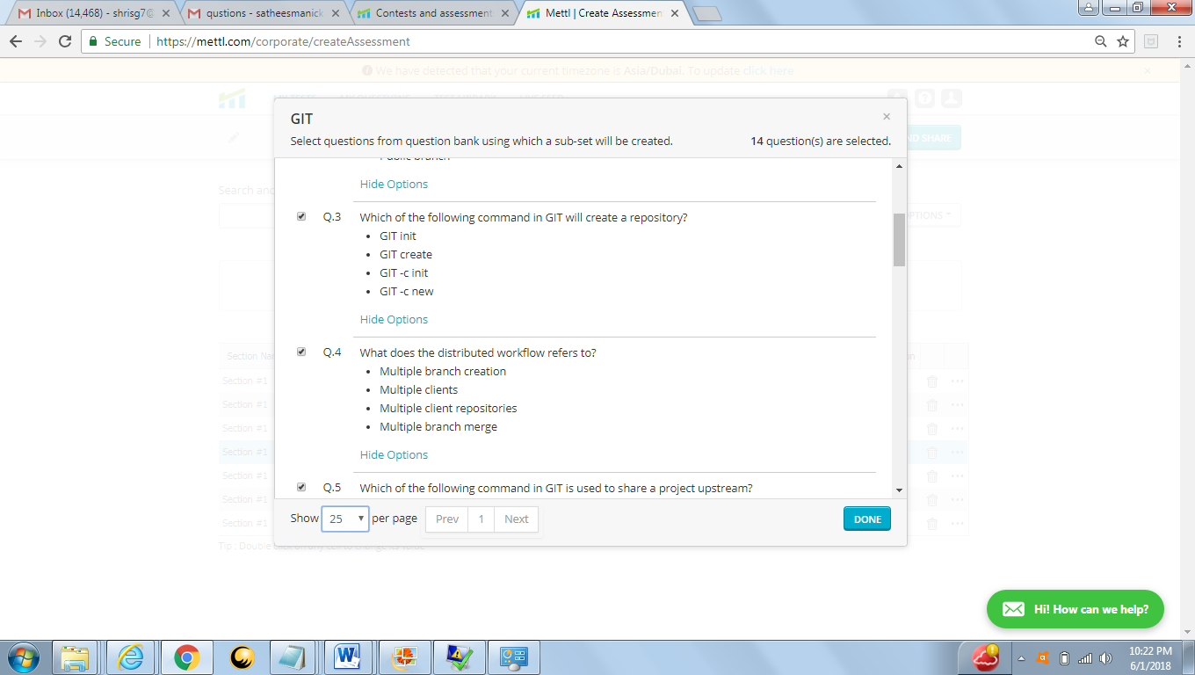

Question 3 : A (Git Init)

Question 4 : C (Multiple Client Repositories )

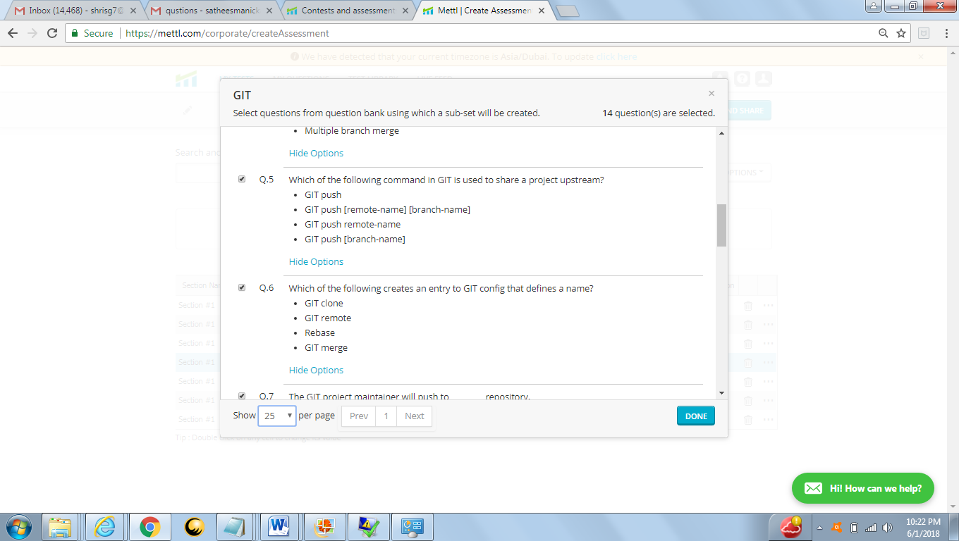

Question 5 : Answer B( Git Push <remote - name><Branch-name>)

Question 6 : Answer B ( Git remote )

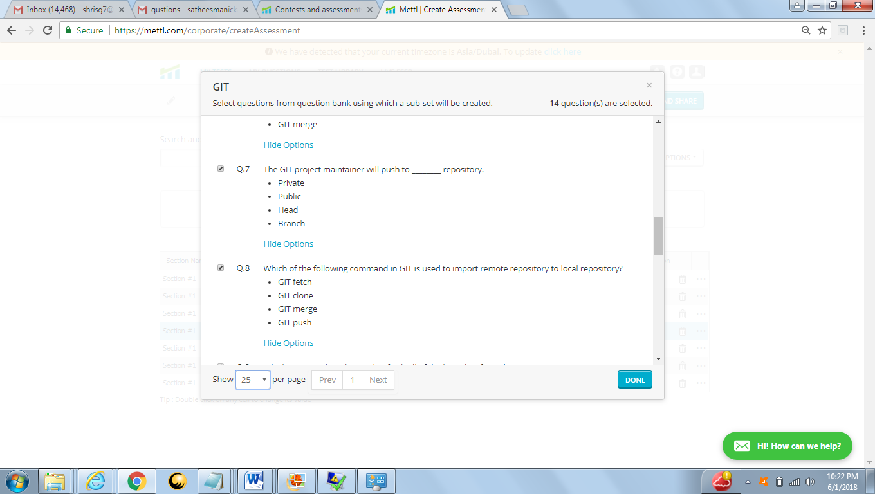

Question 7 : D (Branch)

Qusetion 8 : A( git fetch)

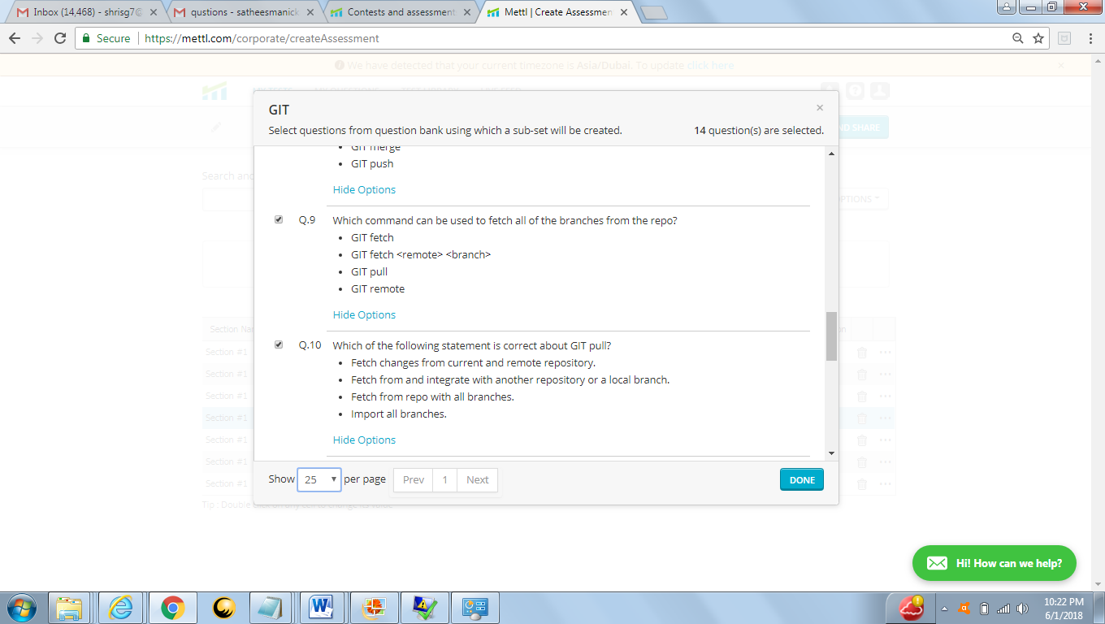

Question 9 : Git Fetch (A)

Qusetion 10 : Fetch Changes from current and remote repository (A)

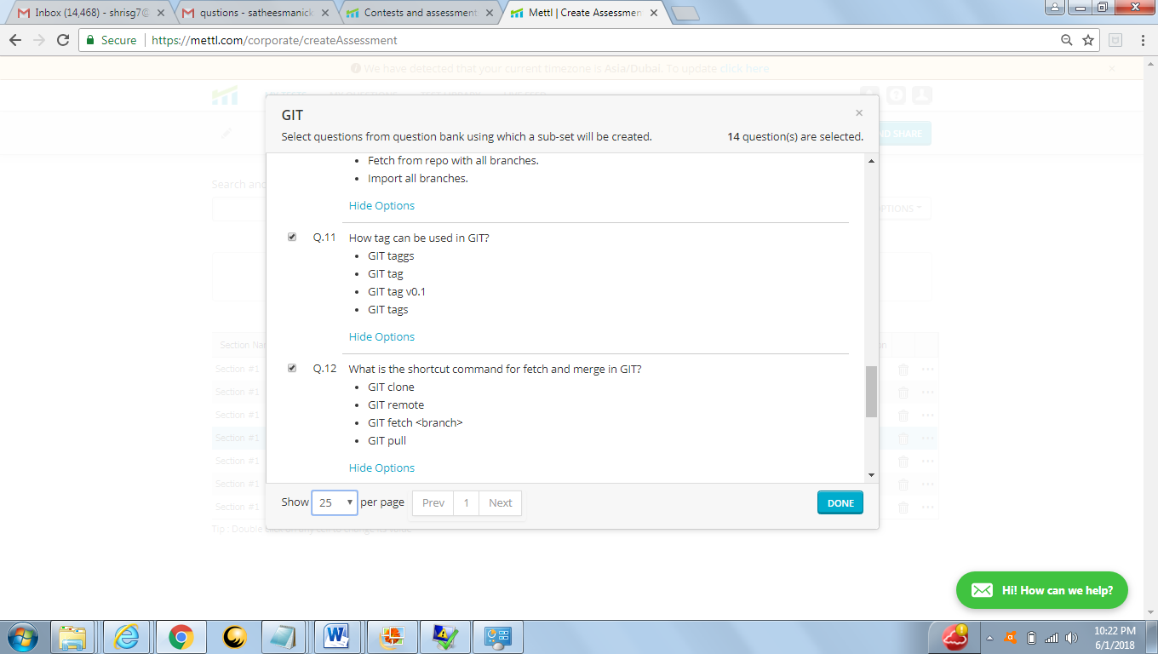

Qusetion 11 : Answer (B) git tag

Qusetion 12 : Answer (D) git PuLL

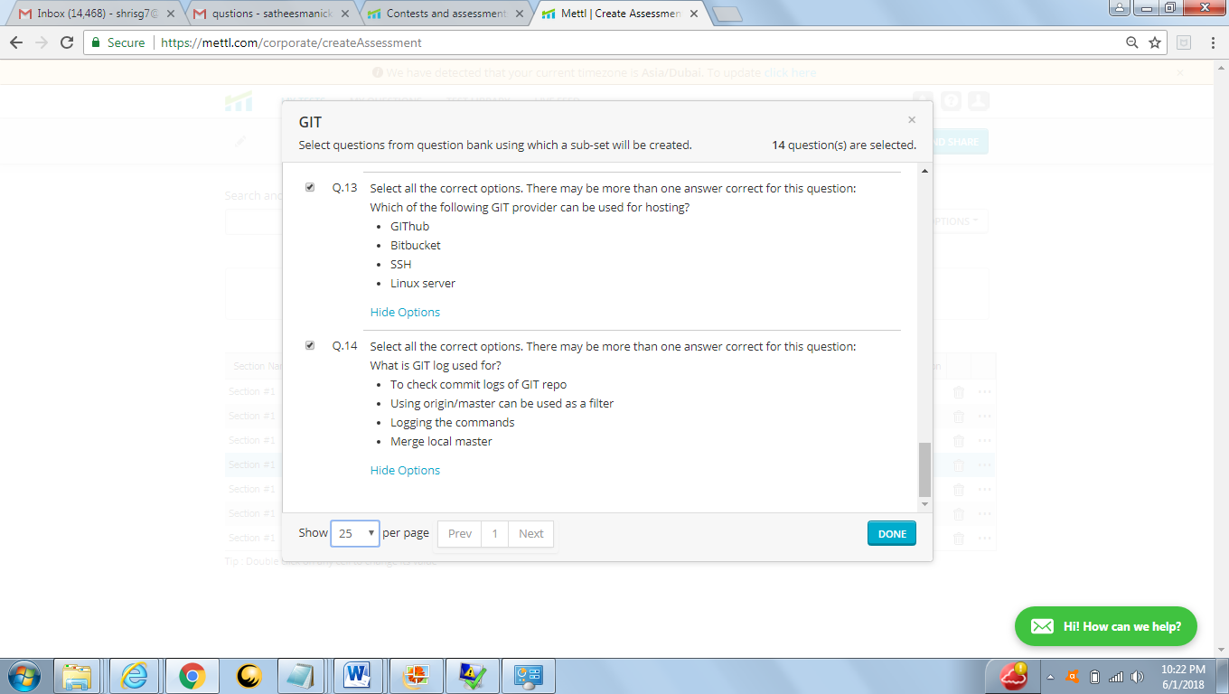

Question 13 : Answer ( A,B) (Github,Bit Bucket)

Question 14 : Answer (A)

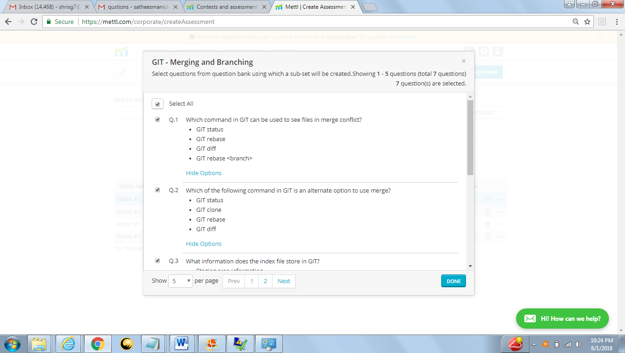

Question 1: Answer (A) git status

Question 2: Answer (C) git rebase

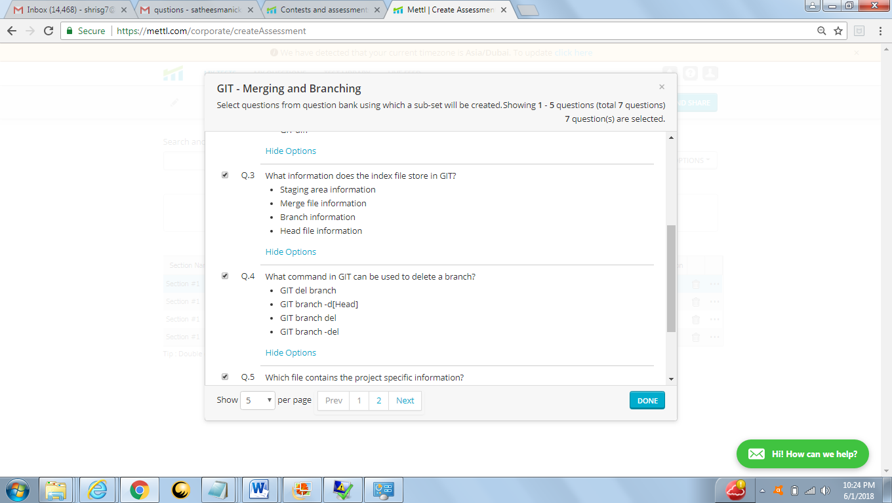

Question 3: A (Staging area information)

Question 4 : B(GIT branch –d(Head))

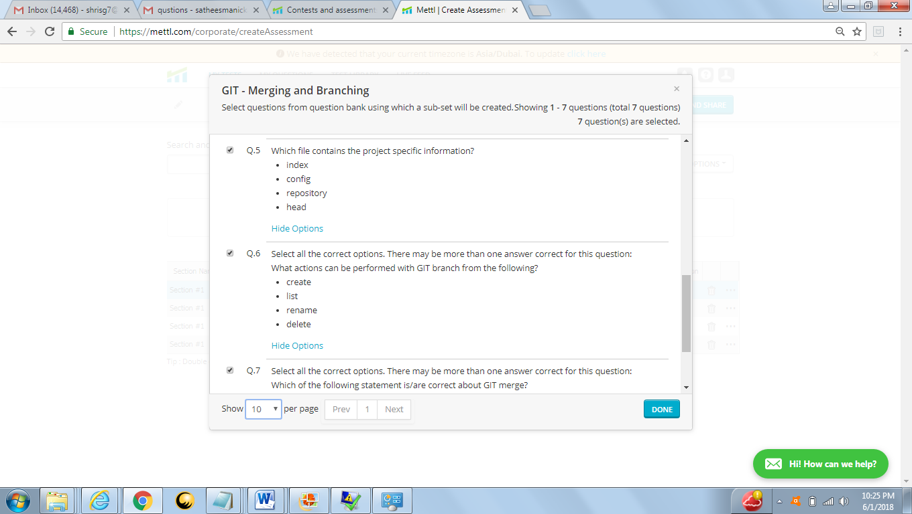

Question 5 : B (config)

Question 6 : (A,B,D)(Create,List,Delete)

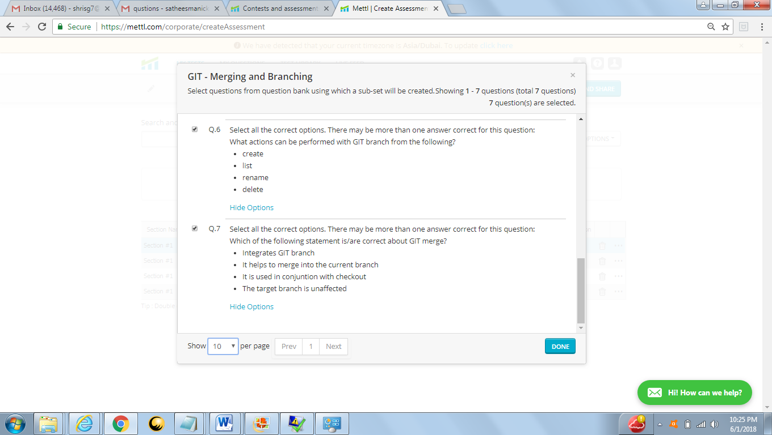

Question 7 : A,B(Integrates GIT branch,it help to merge in to current branch)

For More Information

<https://www.atlassian.com/git/tutorials/setting-up-a-repository/git-clone>

<https://git-scm.com/book/en/v2/Git-Basics-Tagging>